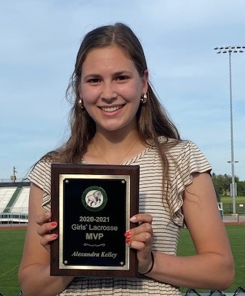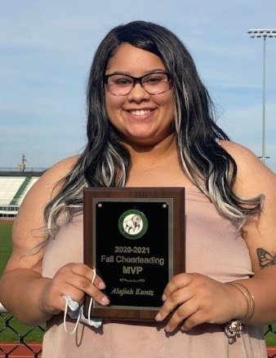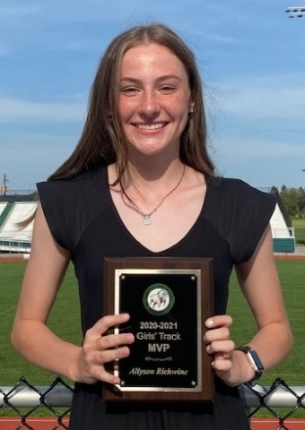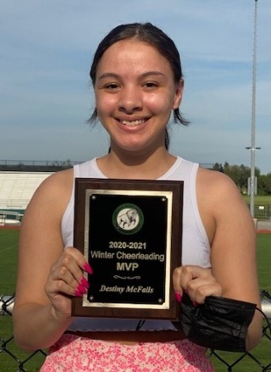
Alexandra Kelley Alajiah Kuntz Allyson Richwine Destiny McFalls
MVP Girls Lacrosse MVP Fall Cheer MVP Girls Track & Field MVP Winter Cheer

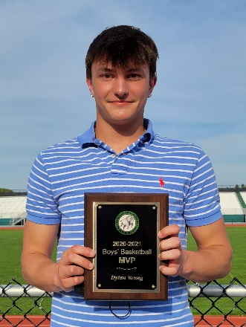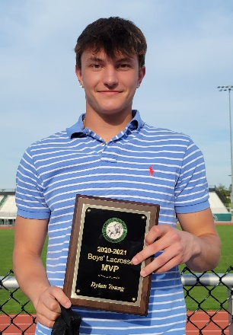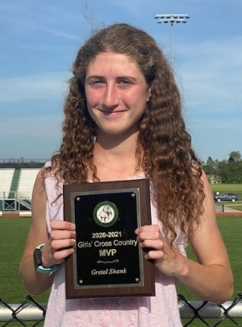
Dylan Young Dylan Young Evan Peachey Gretal Shank
MVP Boys Basketball MVP Boys Lacrosse MVP Boys Cross Country MVP Girls Cross Country

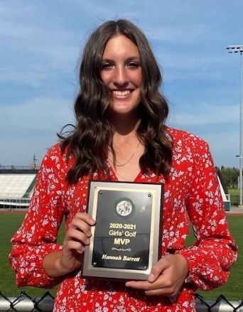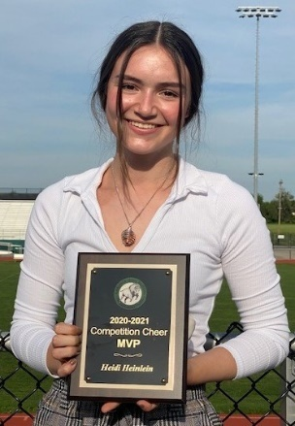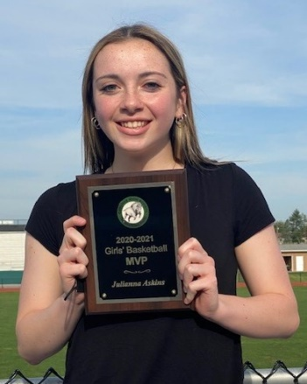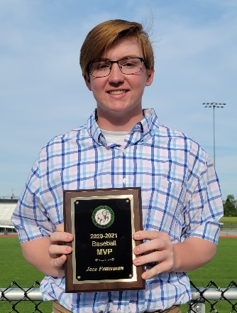
Hannah Barrett Heidi Heinlein Julianna Askins Jace Fetterman
MVP Girls Golf MVP Competition Cheer MVP Girls Basketball MVP Baseball

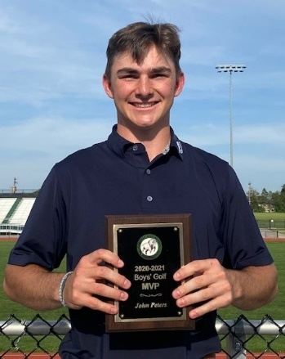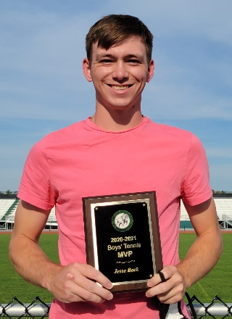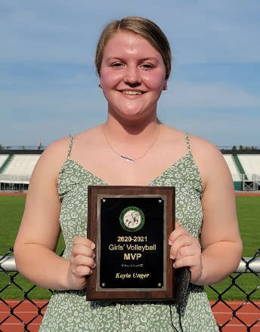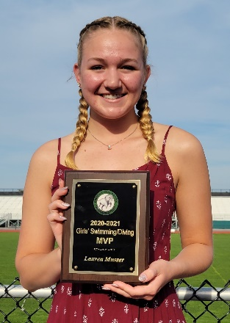
John Peters Jesse Beck Kayla Unger Lauren Musser
MVP Boys Golf MVP Boys Tennis MVP Girls Volleyball MVP Girls Swimming

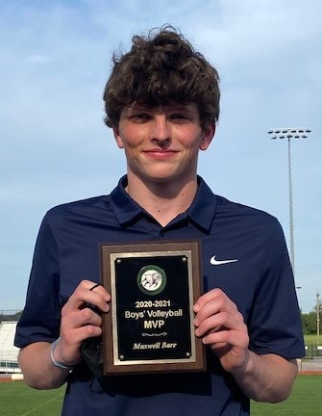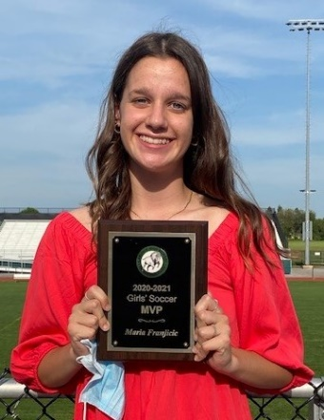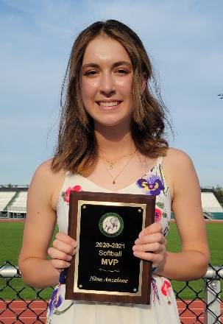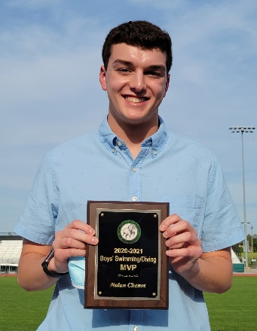
Maxwell Barr Maria Franjicic Nina Anzalone Nolan Chenot
MVP Boys Volleyball MVP Girls Soccer MVP Softball MVP Boys Swimming

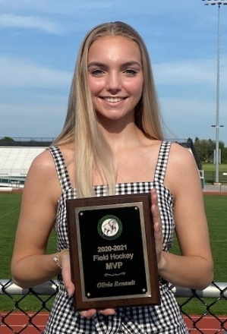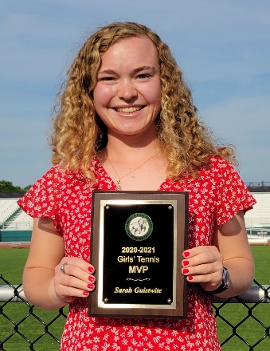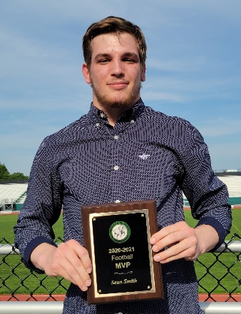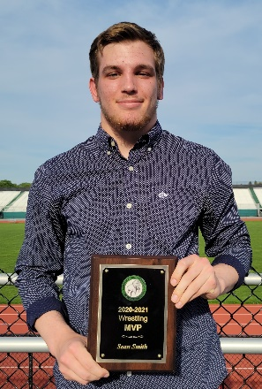
Olivia Renault Sarah Guistwite Sean Smith Sean Smith
MVP Field Hockey MVP Girls Tennis MVP Football MVP Wrestling

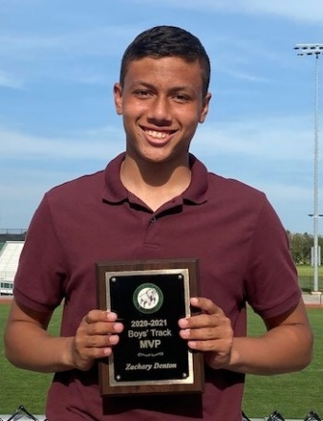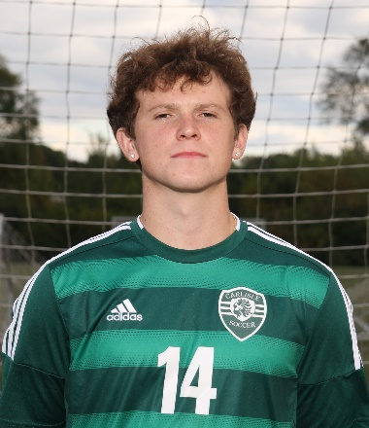
Zachary Denton Zachary Doupe
MVP Boys Track & Field MVP Boys Soccer

