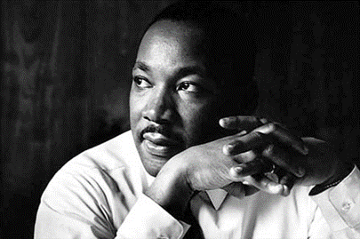
Rev. Dr. Martin Luther King, Jr.
Project and Showcase
2018-2019

“Remember! Celebrate! Act! Uniting to Strengthen Our Single Garment of Destiny”
Background:
In his 1963 “Letter from Birmingham Jail,” Rev. Dr. Martin Luther King, Jr. wrote the following:
“Moreover, I am cognizant of the interrelatedness of all communities and states. I cannot sit idly by in Atlanta and not be concerned about what happens in Birmingham. Injustice anywhere is a threat to justice everywhere. We are caught in an inescapable network of mutuality, tied in a single garment of destiny. Whatever affects one directly affects all indirectly. Never again can we afford to live with the narrow, provincial ‘outside agitator’ idea. Anyone who lives inside the United States can never be considered an outsider.”
Project Prompt:
This year’s theme highlights Dr. King’s message that we are all connected and that to some degree we all have a common destiny. Taking into consideration this year’s theme, its context, and the greater life and work of Rev. Dr. Martin Luther King, Jr. create a project that explores and/or expresses these ideas. Some things to consider:
- Who is the “we” Dr. King refers to?
- What does destiny mean? What should our destiny look like?
- Do you feel like we are all connected, as Dr. King suggests? If so, how? If not, why?
- How exactly might we unite to strengthen our destiny?
- What is King’s message in the speech excerpt above – or in the entire speech? (How) does it apply to our society today?

Possible Formats for Submissions:
- fine arts or performance arts projects
- social action/social justice projects
- whole-school initiatives, events, or projects
- service projects
- videos, essays (analytical, persuasive, or personal), cartoons, short stories, poetry, narratives, letters, multi-media projects, multi-genre projects
- Whatever students can imagine, we will welcome!

Submission Details:
- All projects should be submitted to building principals by Friday, December 7.
- Principals will select an outstanding submission to represent their building at the 2019 Annual Rev. Dr. Martin Luther King, Jr. Commemoration in Carlisle Sunday, January 20, 2019.
- ALL project submissions will be featured on the CASD website.

This project is sponsored by the Carlisle Area Rev. Dr. Martin Luther King, Jr. Committee

