The LeTort Stream is one of the most famous limestone streams in the world! In fact, “LeTort Spring Run is considered by some to be the most challenging stream in the world to fly-fish in, and was prominently featured in the book Fifty Places to Fly Fish Before you Die by Chris Santella. Fishermen come from around the world to try and reel in a big, wild and colorful brown trout…” (http://www.visitcumberlandvalley.com/trip-ideas/the-outdoors/fly-fishers-paradise/).
We are fortunate that this majestic waterway runs through the backyard of Lamberton Middle School. It is with great excitement that I announce to you that your seventh grade child/children will be able to experience the LeTort Stream first-hand in our third annual LeTort Stream Study field trip! Wilson and Lamberton Middle School students will be collecting, testing, and analyzing the health of this ecosystem by partaking in the following stations:
- Benthic macro-invertebrates
- Water Chemistry
- Velocity Stream Study
- Ecosystem Planting
- Microscope Investigation

Please remember that you can access all newsletters and information regarding this trip by going to the CASD district webpage by using the following navigation links: https://www.carlisleschools.org/
Once there, please click on the following: Academics Subject Specific Science LeTort Stream Study Field Experience

We are privileged to have partnered with local businesses, schools, and organizations from the Carlisle Area that are assisting with this hands-on, engaging, and real-world experience for your child/children. Due to generous grants and donations, your child/children will be provided with hip waders, kick nets, D-frame nets, aquascopes, LaMotte testing kits, and so much more during the course of their field trip stream study day. Your child will be working alongside volunteers from ALLARM from Dickinson College, Trout Unlimited, Audubon Society, as well as the LeTort Watershed Authority. We will be having over 400 students going through these stations over the course of this field trip experience so we do run through a lot of materials.

DONATIONS NEEDED:
It is expensive running the various stations and supplying the kits that are used for all 400 students. If you would like to contribute to these field experiences for this year and for years to come, you can send in a tax deductible contribution. You can send your check to CASD, 540 W. North Street, Carlisle PA 17013 - payable to CASD. Please place in the MEMO line “LeTort Stream Study trip.”
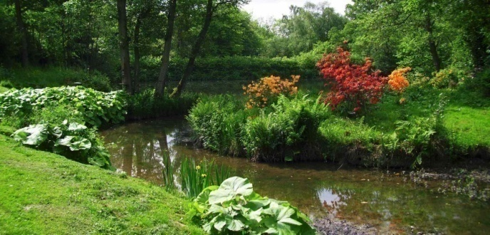
Do you love the outdoors?
Do you enjoy the LeTort Stream?
Do you want to experience the LeTort Stream Field Study first hand with your child?
Do you already have the necessary clearances to serve as a chaperone and/or volunteer for the Carlisle Area School District?
If you answered ‘yes’ to these questions, then we are looking for YOU to join us on any of the field trip dates! We have a lot of staff on hand serving as group leaders, but we need additional personnel throughout the various stations for each field trip day. If you are interested, please email either:
Meg Marchetti: marchettim@carlisleschools.org
Liz Felix: felixe@carlisleschools.org
Allison Thumma: thummaa@carlisleschools.org
Amy Kordenbrock: kordenbrocka@carlisleschools.org
Please check the specific requirements that are necessary in order to serve as a chaperone/volunteer by going to:
district website community volunteer/chaperone
Or by clicking on the following link: https://www.carlisleschools.org/community/volunteer__chaperone/

Please make sure to mark the following dates on your calendars to avoid any conflicts on these dates. The LeTort Stream Study Field Trip dates are as follows:

LAMBERTON MIDDLE SCHOOL:
- 7G: Monday, May 6th -- Ms. Felix
- 7W: Tuesday, May 7th – Ms. Marchetti
Lamberton Middle School students will depart LMS with their teachers and chaperones and walk to the LeTort Park in the morning. At the conclusion of the day, students will depart LeTort Park around 2:00pm to make it back in time for dismissal.

WILSON MIDDLE SCHOOL:*
- 7G: Wednesday, May 8th – Ms. Kordenbrock
- 7W: Thursday, May 9th – Mrs. Thumma
- Wilson Middle School students will be transported to LeTort Park via school bus. All students will check in at 7:50am and board the buses with their respective teams. The buses will leave WMS at 8:00am. Students will be transported back to WMS at the conclusion of their stream study day. Students will depart from the LeTort Park at 2:00pm to ensure they arrive back in time to board their buses back home.

Permission slips will be handed out to students for this field trip. All students will be venturing off of the Lamberton Middle School grounds to hike down the nature trail during the stream assessment station. All students will be accompanied at all times with adult supervision. Wilson Middle School students will also need to complete a permission slip stating that students will be using school -owned transportation to and from the LeTort Stream study site.

Lunch will be a bagged lunch provided by the school cafeteria for your child on their specific field trip date. This will be charged to your child’s account. However, your child may also bring their own bagged lunch from home if they prefer. We will store the bagged lunches in coolers. Lunch orders will be taken by your child’s science teacher!
A bagged lunch from the school cafeteria consists of:
- Sandwich [choices include one of the following]:
Gobbler (turkey)
Hamin’ It Up (ham)
Nutty Buddy (peanut butter & jelly)
- Fruit
- Vegetable

Students must sign up for their choice of bagged lunch with their science teachers by April 26th.
- Please be sure that your students are dressed appropriately for the field trip! They will be getting dirty and most likely, a little bit wet! Please do not send your students wearing expensive/fancy clothing. Skirts cannot be worn on the field trip due to the hip waders.

- If at all possible, send students to school wearing either pants or shorts that have belt loops! This will allow the hip waders to be buckled directly to the pants.

- Encourage your child to wear layers! T-shirts, long sleeve shirts, and sweatshirts are a good option to have, depending on weather conditions! Hats and sunglasses are also encouraged!

- DON’T FORGET THE SUNSCREEN!

- Sending an extra pair of socks is advised! Water will end up finding its way into the bottom of the hip boots over the course of the 4 days. No one likes wet toes so please pack an extra pair! You can certainly send in additional shirts/pants as you see fit.

- Tick season is upon us, so please perform a quick tick check when your child arrives home that day!

- If you want to send a water bottle along with your students, please be sure to write their name on it.

If you should have any questions regarding the LeTort Stream Field Experience, please contact your child’s 7th grade science teacher, or email: Samantha Moyer, Science Program Chair, at moyers@carlisleschools.org
We look forward to providing your student with an incredible field experience they will remember for years to come.

