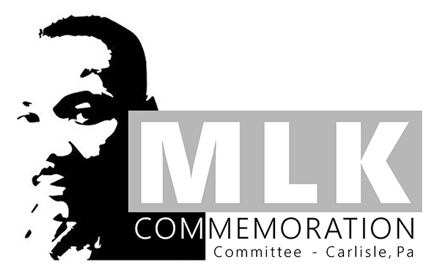

scholarship opportunity

Several scholarships are available. To apply, please complete the steps outlined below.

Step 1 – Fill out the APPLICATION FORM. Please type or print clearly.

Step 2 – Submit the following documents along with the completed APPLICATION FORM:
- A TRANSCRIPT (This may be an unofficial copy obtained from your guidance counselor.)
- LETTERS OF RECOMMEDATION from any two of the following: community leaders, guidance counselor, teacher, priest, minister, rabbi, or church lay leaders
- AN ESSAY that explores the work of Dr. Martin Luther King, Jr. as it relates to this year’s theme (see attached Project information) and discusses how his work might be applied to improve your own community (however you define this). The length of the essay should be determined by its purpose. The essay should be long enough to handle the chosen topic thoroughly and meaningfully without including unnecessary material.

All completed applications and the accompanying documents should be emailed to Mrs. Keely M^{c}Geehan (English Department Head Teacher) @ mcgeehank@carlisleschools.org by Thursday, April 15, 2021.

If you have questions, please contact Mrs. Keely M^{c}Geehan.

MARTIN LUTHER KING, JR. COMMEMORATION COMMITTEE SCHOLARSHIP APPLICATION
Full Name: Date of Birth:
Permanent Address:
Telephone Number : Male _____ Female _____
School from which you will graduate:
School you plan to attend:
School Mailing Address:
Will you be enrolled fulltime? Yes ____ No____ If not, what hours?
What is your career goal?
Please list any academic honors or awards you have received.
In what school, church or community projects and activities have you participated?
What paid employment have you had or do you have now?
Will you be working during the college year? Yes ____ No____
Male Parent/Guardian’s Name and Occupation:
Female Parent/Guardian’s Name and Occupation:
Did either guardian attend college? Yes ___ No___
Did any of your grandparents attend college? Yes ____ No____
Family Income Available to Meet Academic Expenses:
**OPTIONAL**
Are you a member of a church or synagogue? Yes ____ No____
If yes, name of church or synagogue:
How many years have you been a member?____
Signature: Date:

“Pursuing the Dream: Uniting in Truth and Love”
Rev. Dr. Martin Luther King, Jr.
Project and Showcase
2020-2021
Grades K-12

Project Prompt:
This year’s theme, “Pursuing the Dream, Uniting in Truth and Love,” highlights the continued importance of uniting with one another in love. It also urges us to confront the truth of our moment – to examine what continues to divide us in an effort to bring us closer to one another – and closer to Dr. King’s dream.
Create a project that explores and/or expresses this year’s theme, taking into consideration your community (however you define it) as well as the greater life and work of Rev. Dr. Martin Luther King, Jr. Some questions to consider might include:
- How would Dr. King define “the dream”? What does his dream look like today?
- How did Dr. King’s work seek to attain “the dream”?
- What continues to divide us? How can we confront and examine those divisions in order to come closer to one another and to Dr. King’s dream?
- Where in your community do you see evidence of individuals or groups “pursuing the dream”?
- How can you “pursue the dream” within your community?
- How can you acknowledge the truth of our moment while seeking to unite in love?
- Where in your community do you see evidence of individuals or groups confronting the truth of the current moment?
- How can we take Dr. King’s lofty vision and apply it in practical ways within our own community?

Possible Formats for Submissions:
The current circumstances surrounding COVID-19 will impact not only the format of this year’s commemoration event, but also the way in which we will collect entries. To accommodate the nature of this year’s commemoration event, we encourage students to make a simple statement about this year’s theme – perhaps one that responds to one of the questions listed above. A one-sentence response is perfectly acceptable, for example, and the submission form allows for this. However, we will still accept projects in the following forms:

- arts or performance arts projects
- whole-school or all-class initiatives, events, or projects
- social action/social justice project
- service projects
- videos, essays (analytical, persuasive, or personal), cartoons, short stories, poetry, narratives, letters, multi-media projects, multi-genre projects, personal statements
- Whatever students can imagine, we will welcome!

All entries should be submitted electronically via this FORM by Monday, January 4, 2021. If a student completes a poster or other 2- or 3-demensional project, the student should take pictures of the project and attach them to the submission form. Some projects will be featured at the Commemoration event. ALL project submissions will be featured on the Carlisle Area School District website.

